Setting up your Patient Access

By now, you should have been given your registration details to allow you to set up your Patient Access account. If you haven’t received this, speak to your surgery reception. It should look like this:
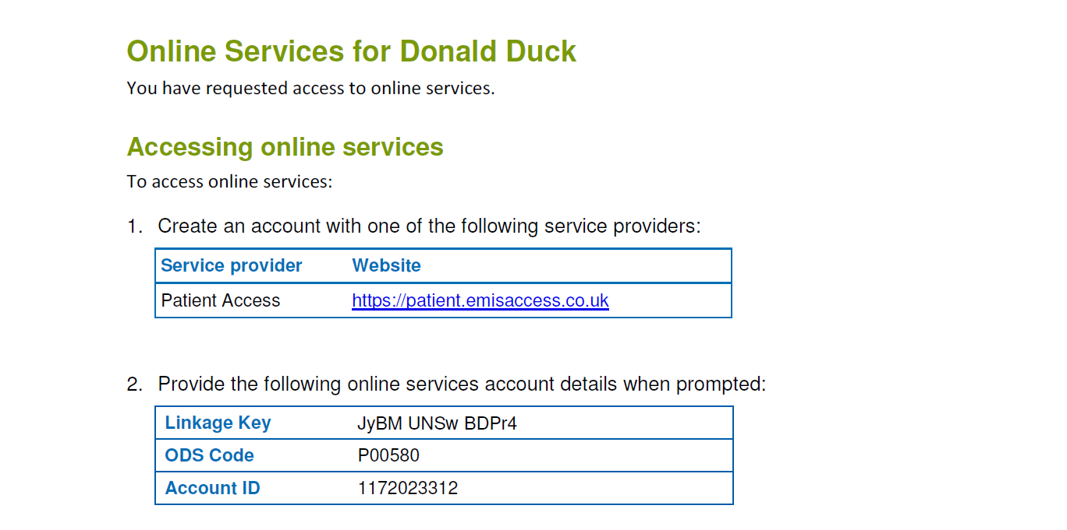
The next step is to go to https://patient.emisaccess.co.uk, and you should see the following page appear. Click on the green “Register” button on the left hand side.

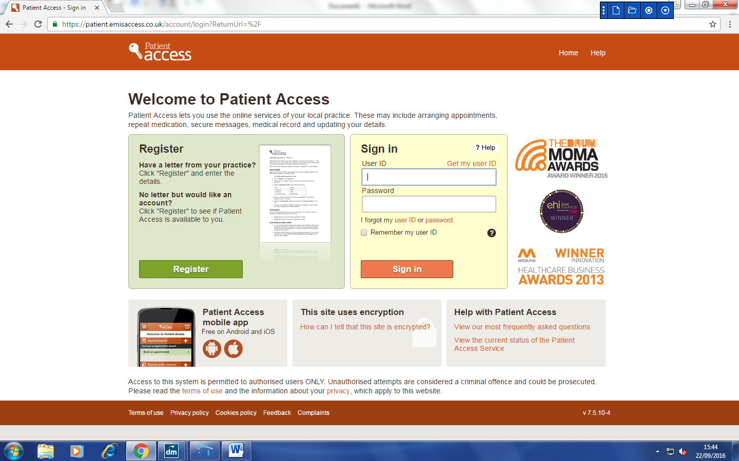

The next page will ask if you have received your registration letter from your practice. You have, so go ahead and tick “Yes”.

Then, it will ask you to fill in some details from your registration letter. Fill these in in the appropriate boxes, and then click on “Next” (if you know your NHS number, then you can fill it in, but if you don’t, leave that box blank, it won’t affect it).

If you’re struggling to find these details, remember that they’re on your registration letter from your practice.

Next, you’ll be asked to fill in your Surname and Date of Birth. You will then be asked to choose a password. This password can be anything you want, and only you will know it, so try not to forget it! Your password must be at least 8 characters long, and contain one Upper-case letter, one Lower-case letter, and one number, e.g. Password1

Once you’ve filled in all these details, tick the box at the bottom to say “I agree to the terms and conditions”, and click on “Next”.

You will need to fill in your contact details and choose some security questions and answers that you will need to remember if you ever need to recover your account.

Once completed, click “Next”, and then you’re registered! Remember to make a note of your user ID and password for when you are signing in.

To get started, click “Sign In”.

Enter your User ID and Password, and click “Sign In”.

To make it easier, you can tick “Remember my user ID” so it will remember you for the next time you log in.

You will then see your Patient Access home screen. Here you can change your password, book an appointment, and order your repeat prescriptions.

Now you’re all ready to go! Remember, if you have any questions or concerns, just contact your surgery reception.

